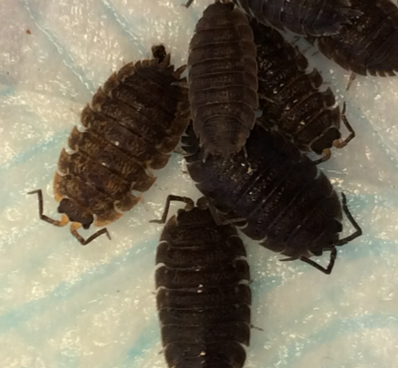
Elvington Primary
School Bug Hunt.

Our science club has been busy hunting bugs, setting up woodlice habitats and investigating different behaviours of woodlice. The science club is made up of students from the foundation stage to year 6 and all work together to support each other using a range of scientific skills after school on a Thursday.
Here is a summary of some of their work:
These are some of the bugs we found in our science garden.
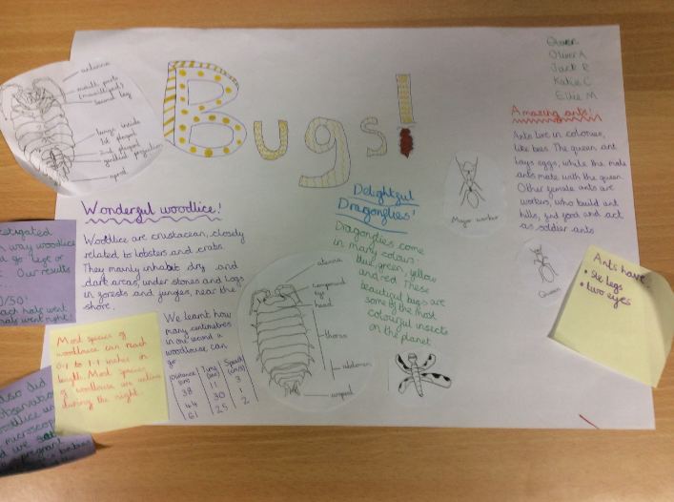

We kept a colony of woodlice in a tub and observed them viewing them under microscopes and with hand lenses. Then we drew them and were amazed to find how they had reproduced.
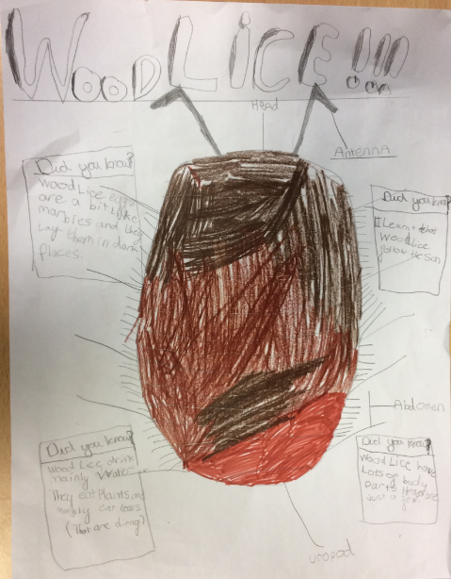
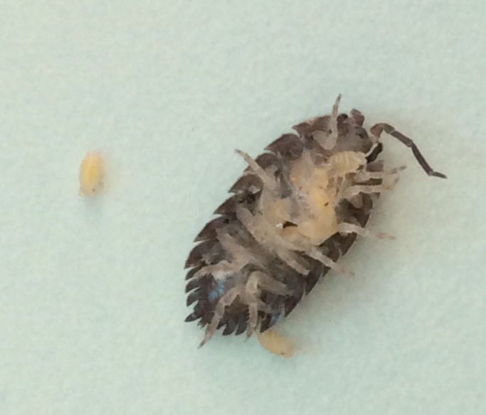

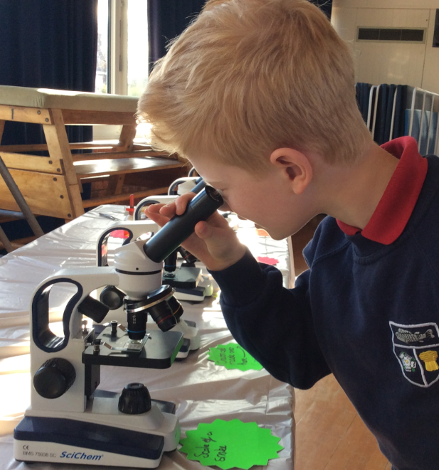

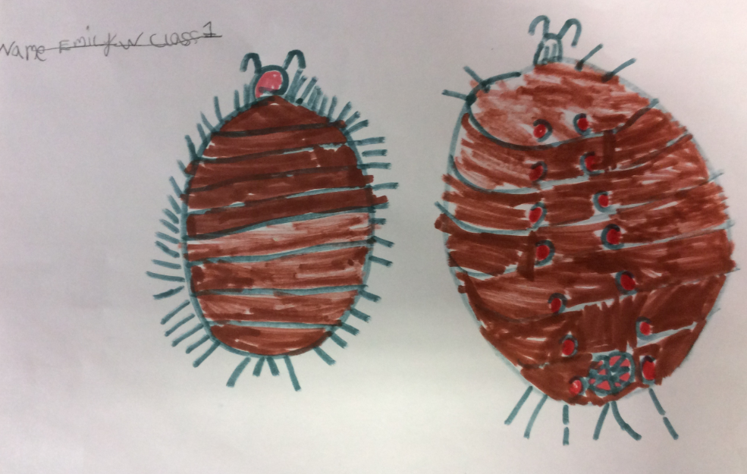

We used 2 meter rules to create a space for the woodlice to run and timed how long it took them to run a certain distance. Then we found out the speed of a woodlice. We discovered that the fastest speed of a woodlice was around 3 cms⁻¹. Here are some of our results.

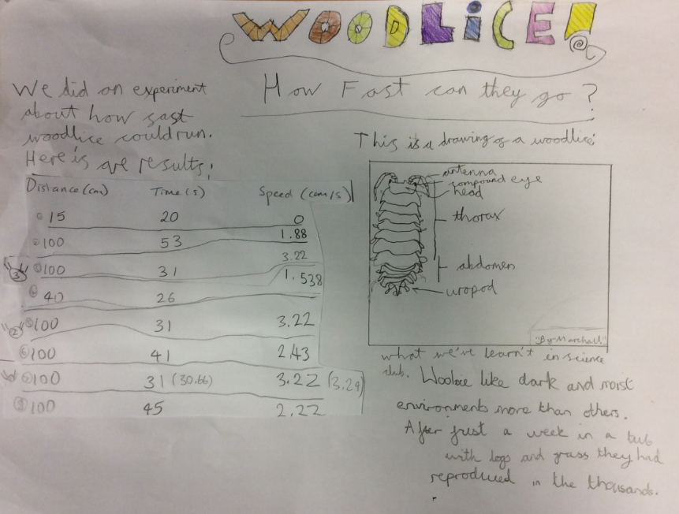

We also used choice chambers to see which environment our woodlice preferred. We set up 4 different environments for them to choose; dark and dry, dark and moist, light and dry, light and moist. In our experiment they all seemed to prefer dark and dry places and huddled together.
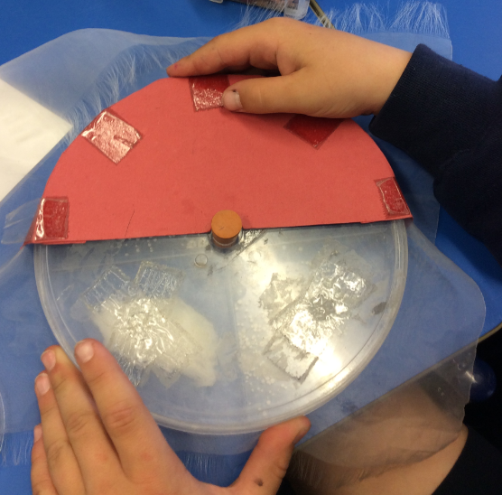
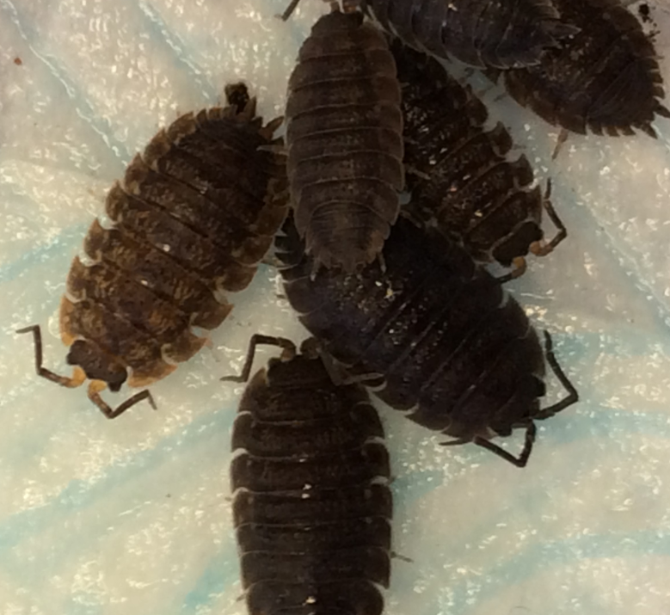

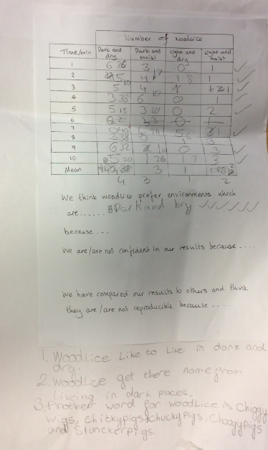

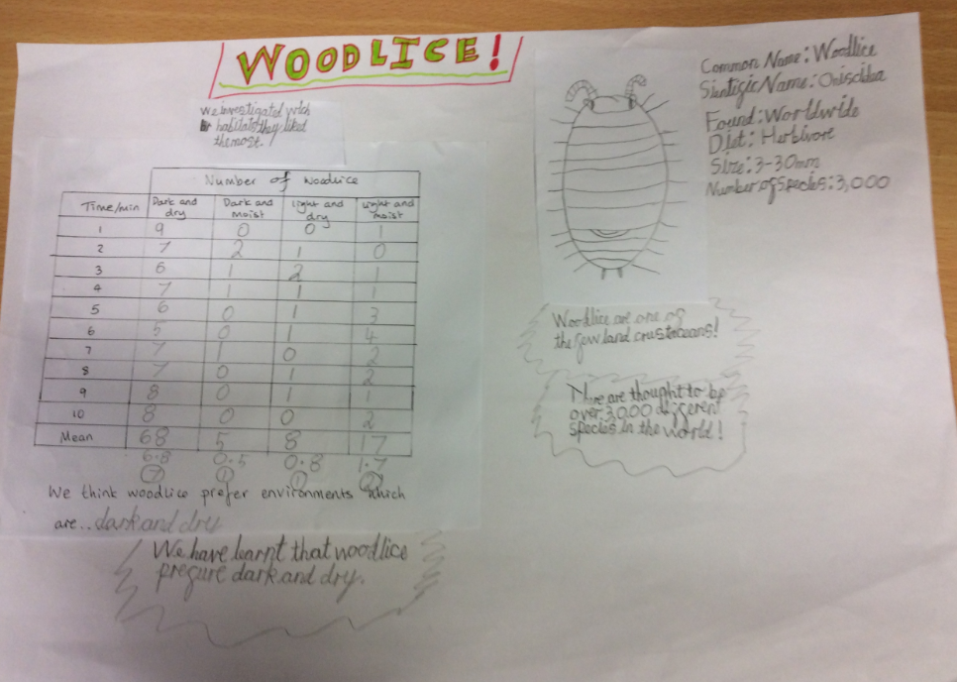

Our final experiment looked at turning behaviour in woodlice. We built mazes from Lego and made woodlice turn right, then we observed whether they turned left or right. We found that if woodlice make a right turn then they mostly make a left turn next. If they made a left turn first then they made a right turn. Alfie and Marshall predicted that this was due to them wanting to find a better environment or food and if they kept turning right then they might end up back at the beginning so making alternate turns was a better idea.
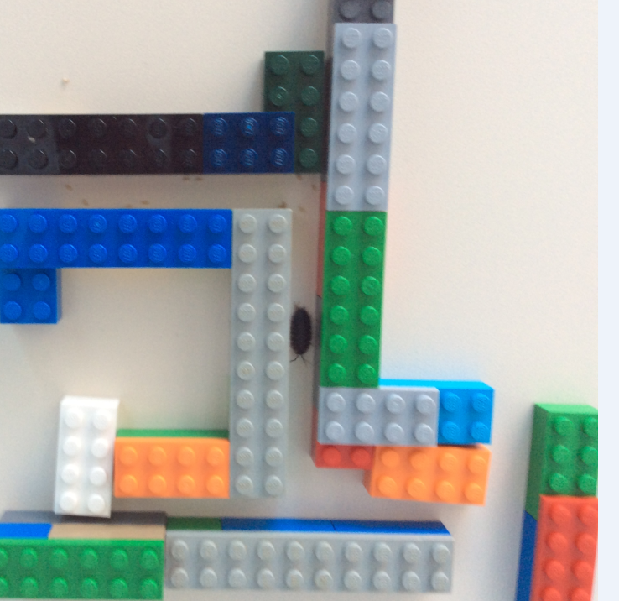
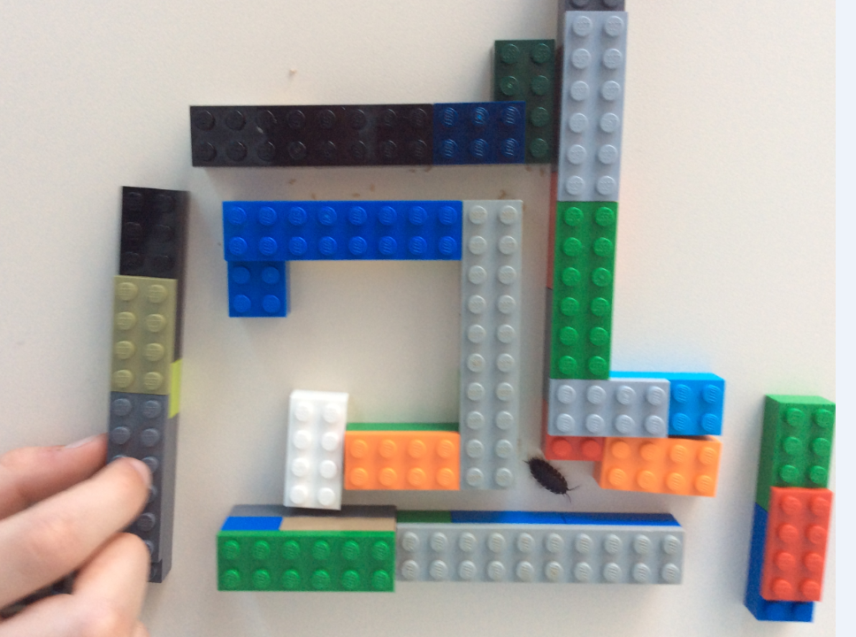

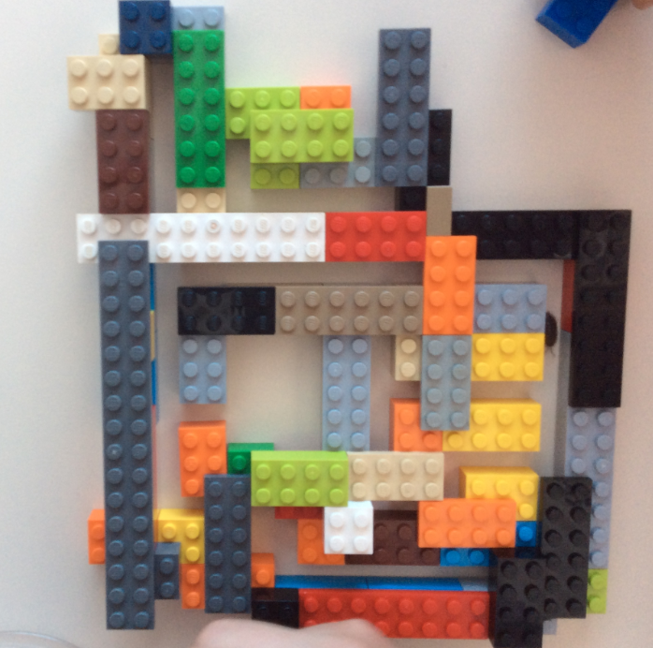
We then made our own mazes to see what they did and they kept making alternate turns.

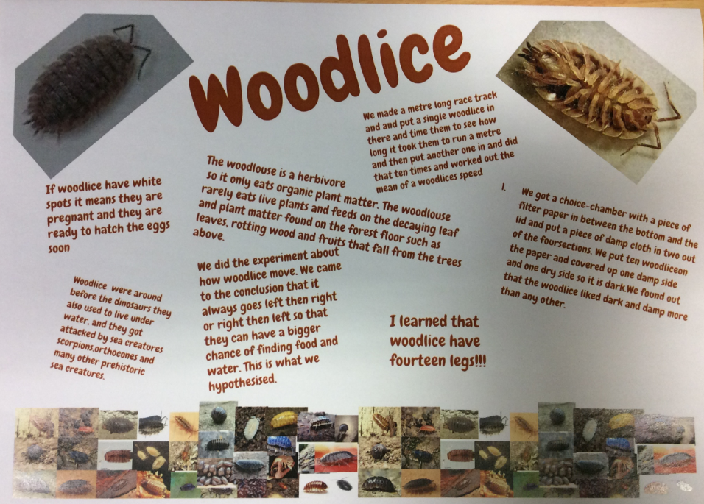

We have love learning about bugs and all the amazing things woodlice can do!

