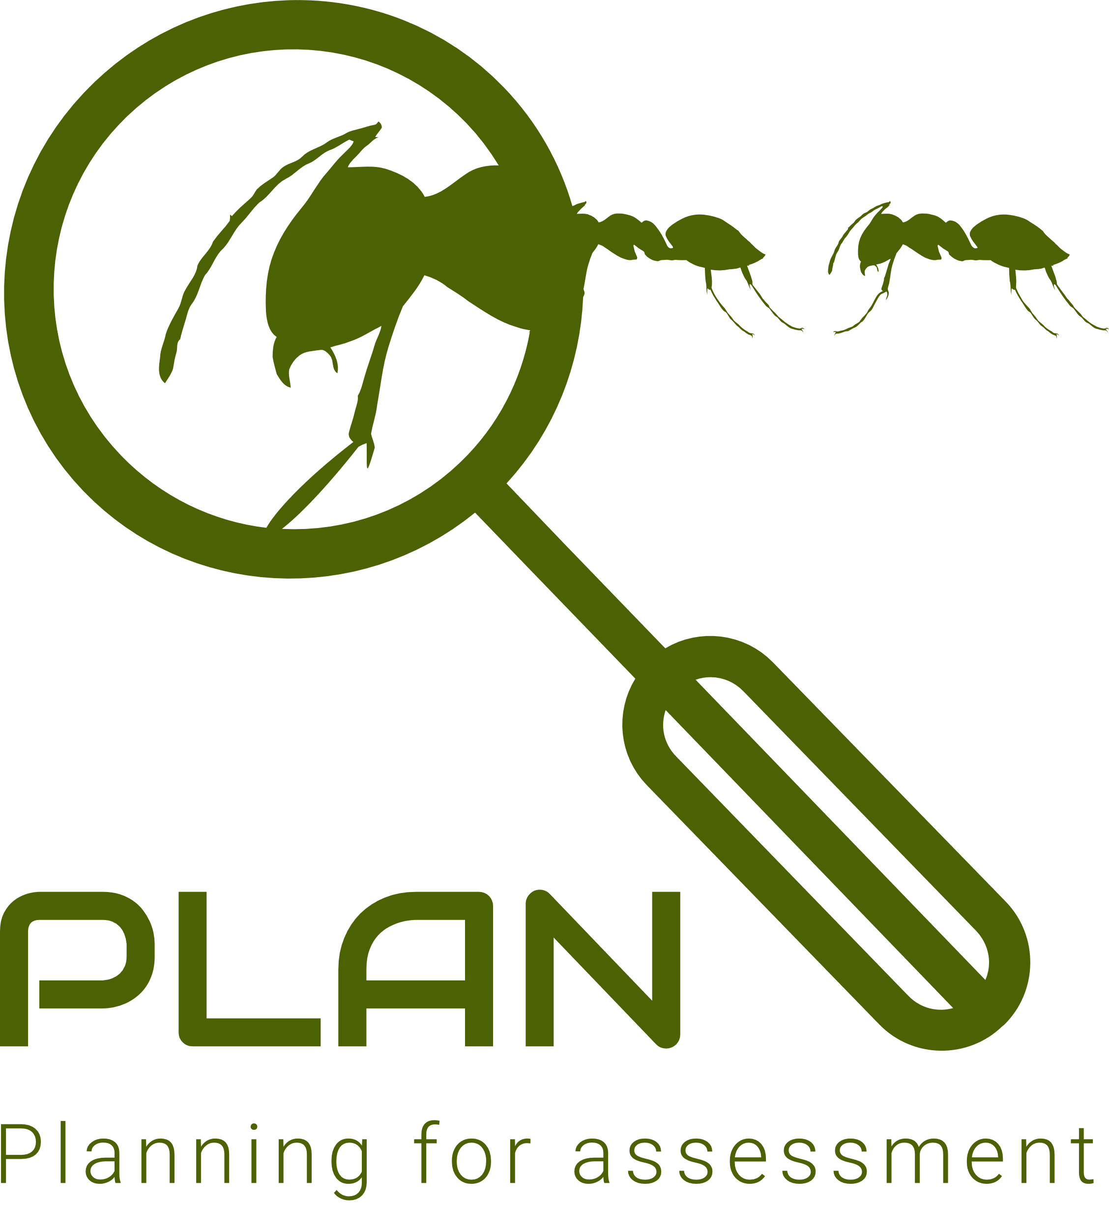 | Working scientifically skills  Year 5 & 6

Planning different types of scientific enquiries to answer questions, including recognising and controlling variables where necessary
- Children independently ask scientific questions. This may be stimulated by a scientific experience or involve asking further questions based on their developed understanding following an enquiry.
- Given a wide range of resources the children decide for themselves how to gather evidence to answer a scientific question. They choose a type of enquiry to carry out and justify their choice. They recognise how secondary sources can be used to answer questions that cannot be answered through practical work.
- The children select from a range of practical resources to gather evidence to answer their questions. They carry out fair tests, recognising and controlling variables. They decide what observations or measurements to make over time and for how long. They look for patterns and relationships using a suitable sample.

Taking measurements, using a range of scientific equipment, with increasing accuracy and precision, taking repeat readings when appropriate
- The children select measuring equipment to give the most precise results e.g. ruler, tape measure or trundle wheel, force meter with a suitable scale.
- During an enquiry, they make decisions e.g. whether they need to: take repeat readings (fair testing); increase the sample size (pattern seeking); adjust the observation period and frequency (observing over time); or check further secondary sources (researching); in order to get accurate data (closer to the true value).

Recording data and results of increasing complexity using scientific diagrams and labels, classification keys, tables, scatter graphs, bar and line graphs
- The children decide how to record and present evidence. They record observations e.g. using annotated photographs, videos, labelled diagrams, observational drawings, labelled scientific diagrams or writing. They record measurements e.g. using tables, tally charts, bar charts, line graphs and scatter graphs. They record classifications e.g. using tables, Venn diagrams, Carroll diagrams and classification keys.
- Children present the same data in different ways in order to help with answering the question.

Identifying scientific evidence that has been used to support or refute ideas or arguments
- Children answer their own and others’ questions based on observations they have made, measurements they have taken or information they have gained from secondary sources. When doing this, they discuss whether other evidence e.g. from other groups, secondary sources and their scientific understanding, supports or refutes their answer.
- They talk about how their scientific ideas change due to new evidence that they have gathered.
- They talk about how new discoveries change scientific understanding.

Reporting and presenting findings from enquiries, including conclusions, causal relationships and explanations of and degree of trust in results, in oral and written forms such as displays and other presentations
- In their conclusions, children: identify causal relationships and patterns in the natural world from their evidence; identify results that do not fit the overall pattern; and explain their findings using their subject knowledge.
- They evaluate, for example, the choice of method used, the control of variables, the precision and accuracy of measurements and the credibility of secondary sources used.
- They identify any limitations that reduce the trust they have in their data.
- They communicate their findings to an audience using relevant scientific language and illustrations.

Using test results to make predictions to set up further comparative and fair tests
- Children use the scientific knowledge gained from enquiry work to make predictions they can investigate using comparative and fair tests.

